Milestone #3

Reports 1 & 2:
- Do enough customers buy equipment to keep equipment sales?
- The first report allows the business owners to see which customers have purchased (not rented) equipment for their trips. They can see customers by name, how many items each customer has purchased, as well as the total amount spent on these items to make their decision on whether equipment sales are providing enough profit overall. The second report is more optional, but it allows the business owners to see how much of each individual item was purchased if they would like to see which inventory is the least popular.

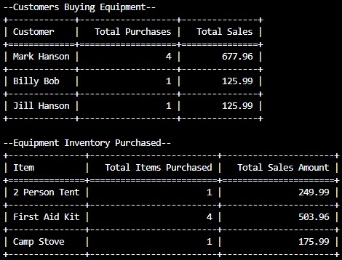

Reports 3 & 4:
- Are there any inventory items that are over five years old?
- There are two reports to answer this question, one which displays rentable equipment and one which displays new equipment. These tables only display items that have been in inventory for over 5 years from the current date, as well as their item ID to distinguish that specific item from others of its kind for easy removal/inspection. It will not display any items newer than 5 years old.

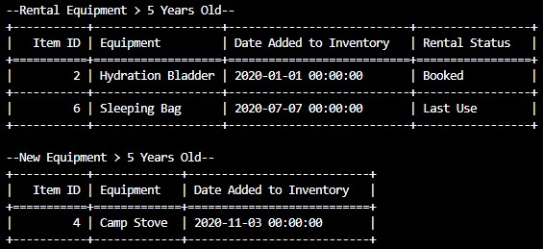

Report 5:
- Is there any one region (Africa, Asia, or Southern Europe) that has a downward trend in bookings?
- This question can be answered by a single report. Each booking has been labeled by which region it was in, and the total number of bookings are added together for each region. In our example database, all the bookings are within the Africa region.

